EXPERIMENT 3
IMPLEMENTION OF POLYALPHABETIC CIPHER

Aim:
To implement the Vigenère (Polyalphabetic) Cipher using Python.

Algorithm:
• Read the plaintext.
• Read the keyword.
• Repeat the keyword to match the text length.
• Encrypt the text.
• Decrypt the text.
• Display the results.

Code:
plaintext = input("Enter Plain Text: ").upper()
key = input("Enter Key: ").upper()

encrypted = ""
decrypted = ""
key_index = 0
for ch in plaintext:
if ch.isalpha():
shift = ord(key[key_index % len(key)]) - ord('A')
encrypted += chr((ord(ch) - ord('A') + shift) % 26 + ord('A'))
key_index += 1
else:
encrypted += ch
key_index = 0
for ch in encrypted:
if ch.isalpha():
shift = ord(key[key_index % len(key)]) - ord('A')
decrypted += chr((ord(ch) - ord('A') - shift) % 26 + ord('A'))
key_index += 1
else:
decrypted += ch

print("\nEncrypted Text :", encrypted)
print("Decrypted Text :", decrypted)

Output:
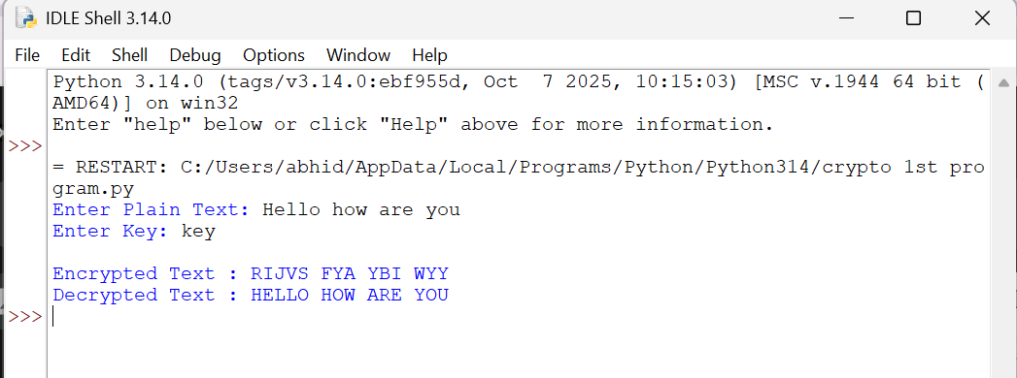
Result:
Thus, the Vigenère (Polyalphabetic) Cipher was implemented successfully
using Python.s

